Table of Contents

“Short Version” (Websites, emails, social media, blurbs, utility bills)................................................................2-4
- 35 Words, 251 Characters, 0 Graphics
- 39 Words, 259 Characters, 0 Graphics
- 53 Words, 274 Characters, 0 Graphics
- 47 Words, 295 Characters, 0 Graphics
- 127 Words, 832 Characters, 0 Graphics
- 78 Words, 545 Characters, 0 Graphics
- 72 Words, 455 Characters, 0 Graphics
- 96 Words, 612 Characters, 0 Graphics
- 101 Words, 660 Characters, 0 Graphics

“Long Version” (Newsletters, articles, inserts, flyers)…........................................................ 5
- 311 Words, 1972 Characters, 1 Graphic

Short Versions: Websites, emails, blurbs, social

1
Know how to protect yourself from earthquakes, whether you live, work, or travel to an area where earthquakes are common. Practice earthquake safety with your community - join in Great ShakeOut Earthquake Drills today: ShakeOut.org/register

***
2

Are you prepared? What we do to prepare now, before the next big earthquake, will determine how well we can survive and recover. Register for Great ShakeOut Earthquake Drills at ShakeOut.org/register to join your community in practicing earthquake safety.

***
3

When the ground starts to shake, what do you do? If it involves a doorway, a triangle, or running - these are not earthquake-safe actions. Register now at ShakeOut.org/register to learn more about Drop, Cover, and Hold On and practice updated earthquake safety actions.

***
4

After an earthquake, have you ever thought, “I was lucky”? Don’t leave it to luck! Get the facts on how to protect yourself during the shaking. Register at ShakeOut.org/register to practice earthquake safety and join a community of millions who are improving their level of preparedness too.

5
The International ShakeOut Day, every third Thursday of October, is a day of individual and community events featuring the largest earthquake drill ever, organized to inspire others to get ready for big earthquakes, and to prevent disasters from becoming catastrophes. What we do to prepare now, before the next big earthquake, will determine how well we can survive and recover. ShakeOut will occur in houses, workplaces, schools, and public spaces on October 21, 2021.

Register at ShakeOut.org/register to involve your family or organization. You will receive information on how to prepare for earthquakes and what actions to take during and after the shaking, as well as other ShakeOut news and updates. You can also see who else is participating in your community at ShakeOut.org/whoisparticipating.

***
6

On October 21, 2021, millions of people will participate in the largest earthquake drill ever: ShakeOut! Why? Earthquakes can happen anywhere you work, live, or travel, which is why everyone, everywhere should know how to protect themselves should an earthquake occur.

Register at ShakeOut.org/register to practice and improve your level of earthquake safety.

Everyone, everywhere can participate! Individuals, families, businesses, schools, government agencies and organizations are all invited to join on 10/21.

***
7
On October 21, 2021, millions of people will practice Drop, Cover, and Hold On through ShakeOut. Many people and organizations will also practice other aspects of their emergency plans.

In 2019, more than 66 million people participated in Great ShakeOut Earthquake Drills. The International ShakeOut Day is every third Thursday of October each year.

Register now: ShakeOut.org

What we do now determines how well we can survive and recover later.

***
8
Earthquakes may happen anywhere you work, live, or travel. Great ShakeOut Earthquake Drills are our chance to practice together how to protect ourselves, and for everyone to become prepared. The goal is to save lives and prevent disasters from becoming catastrophes.

On 10/21, join millions of participants who want to take earthquake-safe action when seconds count. In order to act quickly, you must practice what to do – ShakeOut is that opportunity. Register for free at ShakeOut.org/register to learn more about what to do.

Invite friends and family to practice for their safety, too!

***
9
In an earthquake, you may only have seconds to protect yourself before strong shaking knocks you down, or something falls on you. Practice earthquake-safe actions on October 21. Why? Because when the adrenaline kicks in, you may not act safely if you haven’t practiced the Drop, Cover, Hold On drill before that moment. Don’t wait until the shaking – register at ShakeOut.org/register to practice earthquake safety with your community.

Invite everyone who matters to you to register and ShakeOut on October 21. Everyone is welcome to participate - individuals, families, businesses, schools, government agencies and organizations!

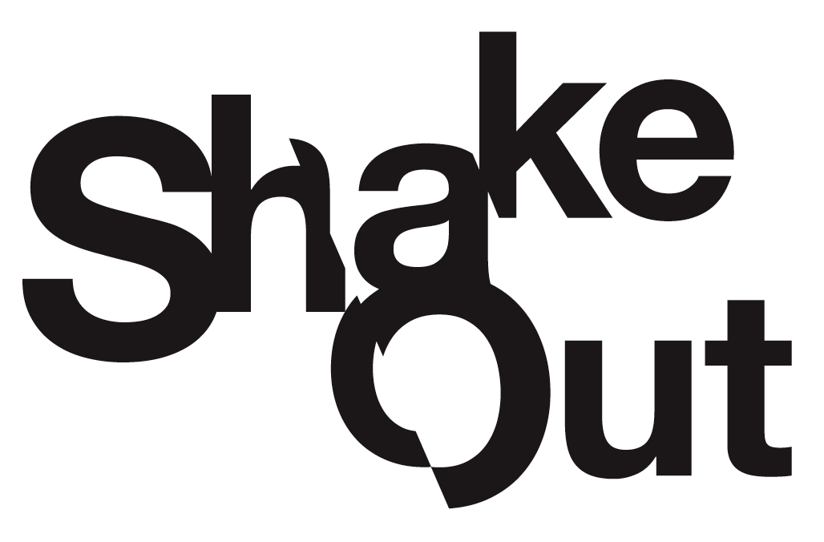Are You Ready to ShakeOut?
With 330 million people living and working in the United States, a major earthquake could cause unprecedented devastation. What we do now, before a big earthquake, will determine how well we survive and recover.
Great ShakeOut Earthquake Drills in October 2019 involved more than 66 million participants through broad-based outreach programs, media partnerships, and public advocacy by hundreds of partners. The drill is held annually on the third Thursday of October. This year, International ShakeOut Day will be on October 21.
A key aspect of the ShakeOut is the integration of comprehensive science-based earthquake research and the lessons learned from decades of social science research about why people get prepared. The result is a “teachable moment” on par with having an actual earthquake (often followed by increased interest in getting ready for earthquakes). ShakeOut creates the sense of urgency that is needed for people, organizations, and communities to get prepared, to practice what to do to be safe, and to learn what plans need to be improved.
Not just any drill will accomplish this; it needs to be big. It must inspire communities to come together. It must involve children at school and parents at work, prompting conversations at home. It must allow every organization, city, etc., to make it their own event. We are all in this together.
The 2021 ShakeOut drill will be the largest preparedness event in world history. To participate, go to ShakeOut.org/register and pledge your family, school, business, or organization’s participation in the drill. Registered participants will receive information on how to plan their drill and involve others. At the minimum practice "Drop, Cover, and Hold On" on the specified date, which is 10/21 this year. It is only a one-minute commitment for something that can save your life.

For more information, visit ShakeOut.org.

